SYED RIBAL HASHMI

CMS ID: 4011-2024

AICT ASSIGNMENT #09

**Lab Tasks:**

Q1: Design a user-friendly form using HTML and CSS.

HTML#

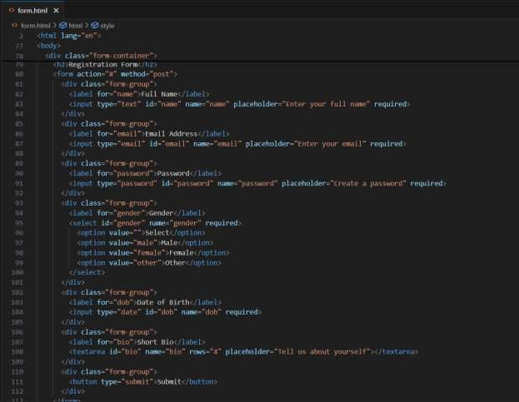

CSS#

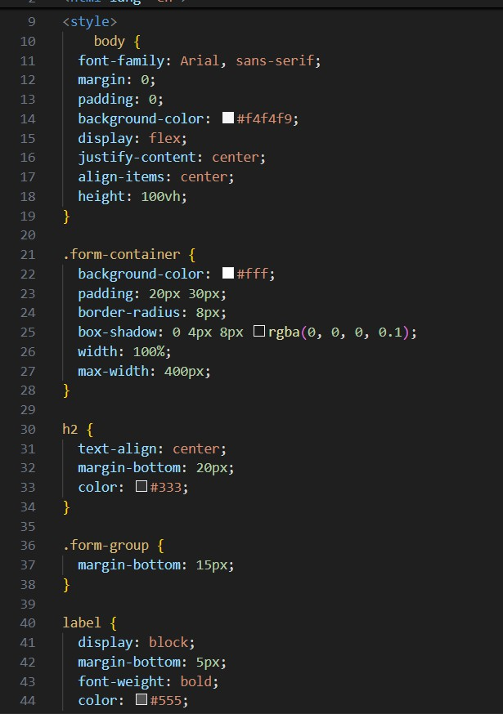

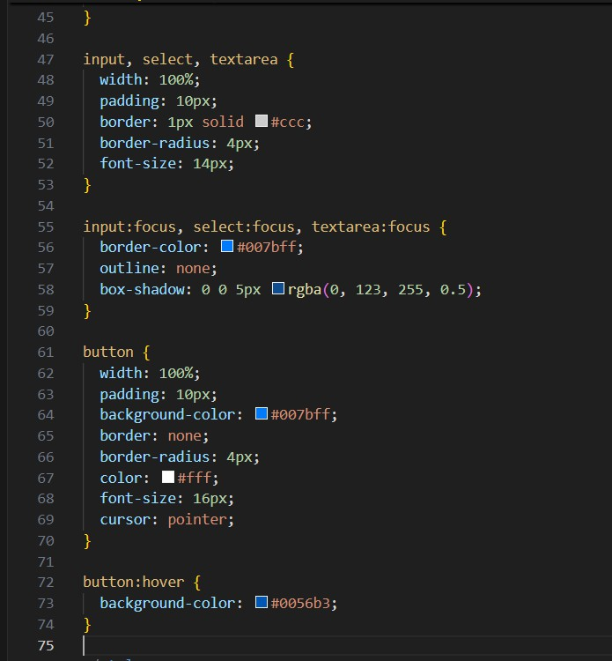

OUTPUT#

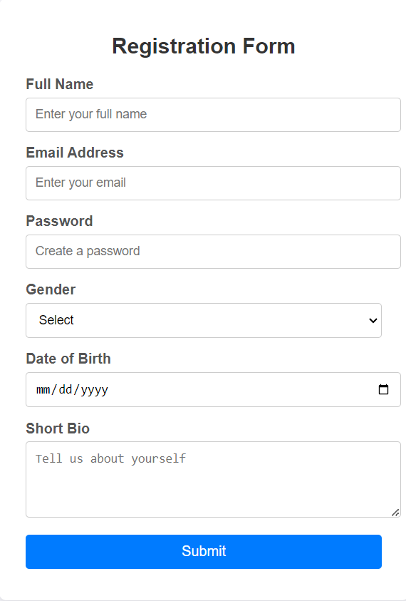

Q2. Use CSS Flexbox to create a responsive and functional navigation bar Requirements:

Create a horizontal navigation bar with links: **Home, About, Services, Blog, and Contact**. Include a logo on the left side and the navigation links on the right side.

**HTML#**

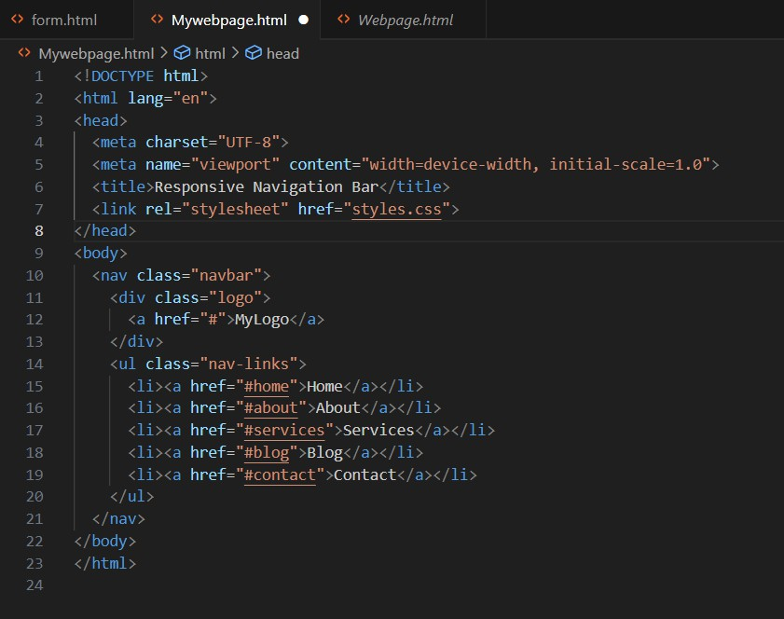

**CSS#**

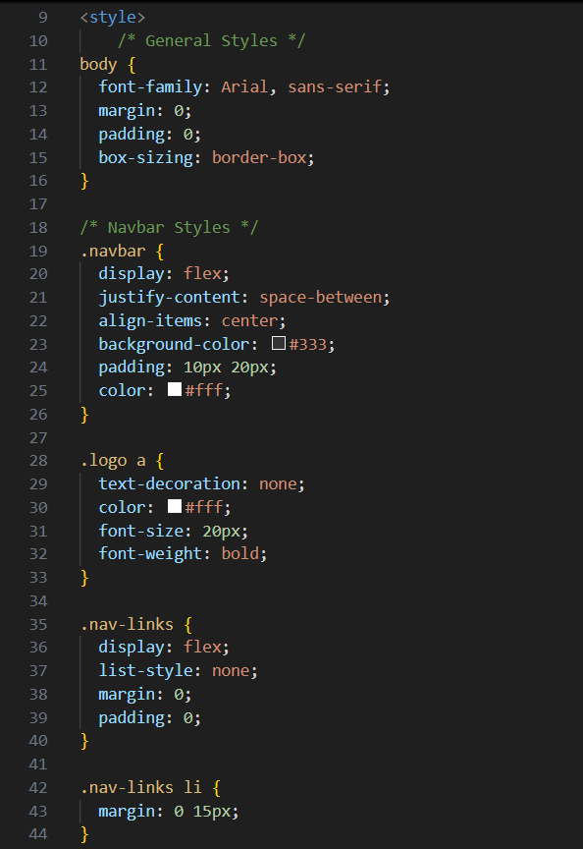

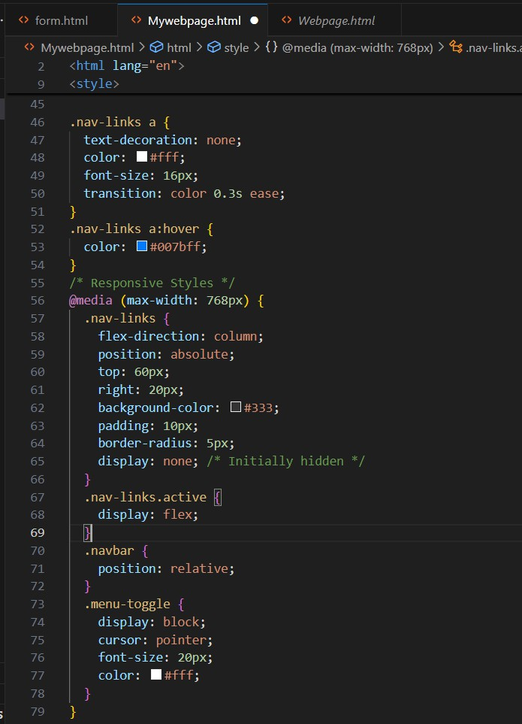

**OUTPUT#**



**Q3. What are media queries in CSS, and what is the purpose of using them in web design?**

**CODE#**

